Design Document

League Management

Vid Barbaro

Date : 22.12.2021
Version : 1.1
State : State
Author : Vid Barbaro

Table of Contents
1. Project Description 3
1.1 Project 3
1.2 Overview 3
2. Wireframes 4
2.1 Home page 4
2.2 Standings page 5
2.3 Statistics page 5
2.4 Fixtures page 6
2.5 Results page 7
3. Design decisions 8
3.1 Why Spring Boot? 8
3.2 Why Angular? 8
3.3 Why MySQL? 8
4. C4 Architecture Diagrams 8
4.1 C1 – System Context 8
4.2 C2 - Containers 9
4.3 C3 – Component Diagram 10
4.4 C4 – Class Diagram 10

Project Description

Project

The project I am building is a football league managment web application, that is going to be used to simplify the happenings on the matches as well as player transfers, goals and other statistics and league news. The website is built for both fans and team members as well as referees. There is a fixed amount of teams that can request to join the league and the league manager can then choose who to accept and who to reject.

Overview

There are a lot of functionalities for a variety of user types. The user types are as follows: non-logged in user, player, team manager, referee, league manager and admin.
A non-logged in user doesn’t have any functionalities, he can only view results, fixtures, standings and statistics and he can log in or register as a player, team manager or referee.
A player can view his upcoming matches, his played matches, his teams standings and his personal statistics with the amount of minutes he played, goals he scored, assists, yellow/red cards he received. Players should be able to accept transfer offers from other team managers and that way they can switch teams.
Team managers can request up to a certain number of players to join their team, they can also release players from their team. Team leaders need to enter their starting line up before a match starts and they can request for matches to be postponed. They have the functionalities of viewing their team statistics as well as individual player statistics. If the referee accidentaly entered wrong information about a played match like the score, goal scorers and yellow/red cards the managers can request to change this information to the correct one.
The referees have an overview of the matches they are the referee at as well as where the match will take place and at what time. After the match they have to enter the match result, goal scorers by jersey numbers for each team, substitutions that happened and yellow/red cards that occured in the game as well as the description of the incident.
League managers can accept teams into their league as requested by the team managers, they can view submisions from referees concerning yellow/red cards and they can determine the amount of match bans for that player. League managers should also be able to postpone matches as per requests of the team managers, and they should also be able to start a new season as well as end the current one.
The admin can perform CRUD functionalities on all of the above mentioned users.

Wireframes

Home page

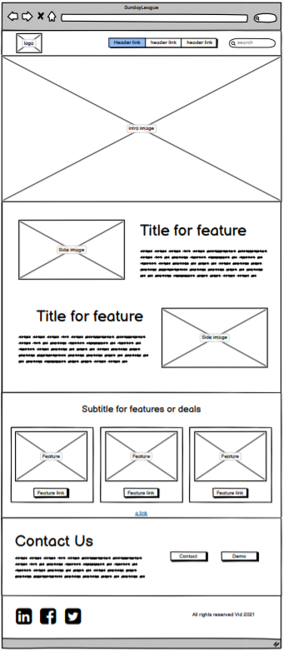

Standings page

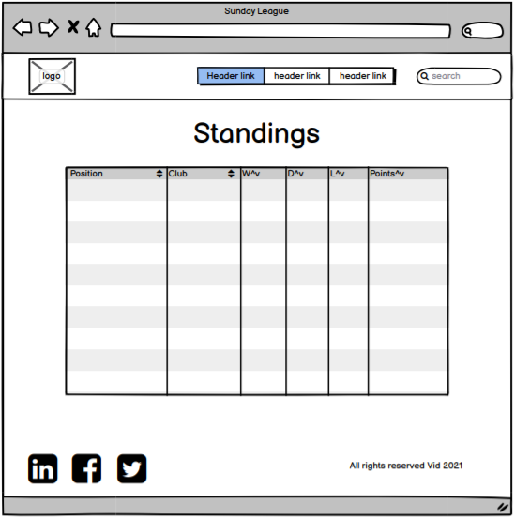

Statistics page

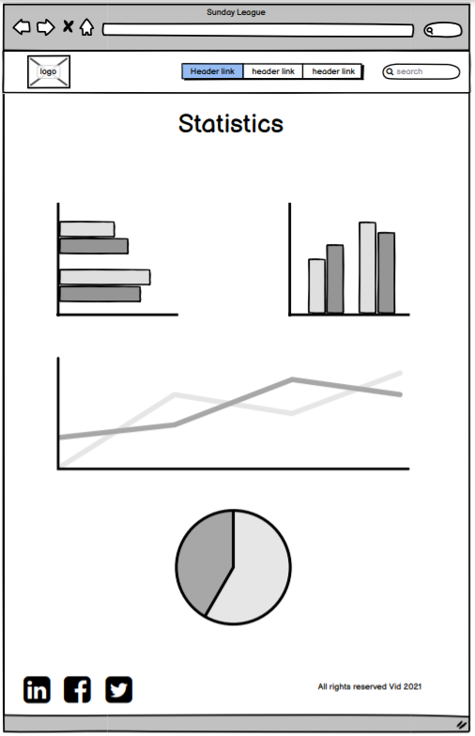

Fixtures page

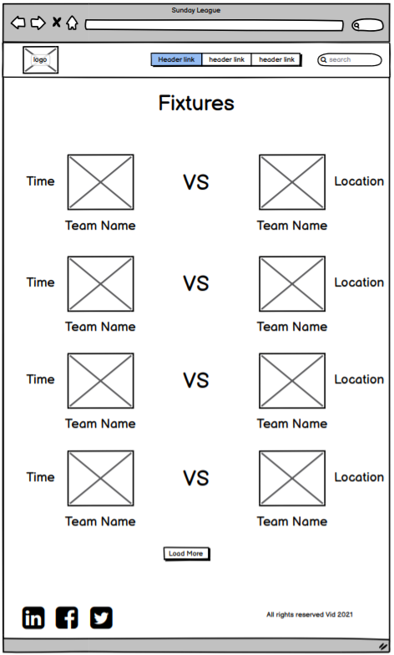

Results page

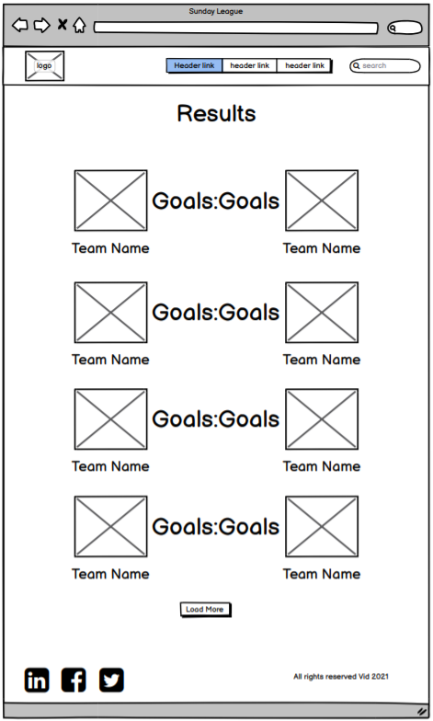

Design decisions

Why Spring Boot?

Using Spring Boot as the framework for the backend of my application offers a lot of advanteges, and the major one being a big community and a lot of good documentation on the framework. A lot of problems developers experience have probably already been asked and solved by somebody else so it saves a lot of time. One of the major features is that it has embedded web servers so as a developer there is no need to worry about deploying the web app on a traditional app server.
For almost all Spring Modules there is a started dependency that configures everything for the develper ad that saves a lot of time and struggle.
Spring Boot has a lot of built in modules that help both with connecting easily to the frontend and the database in a safe, secure and simple way.

Why Angular?

Angular is one of the 3 major JS frameworks for developing frontend UI designs along with React and VUE. What Angular offers over the other 2 frameworks is easier testing since it automatically generate test files together with the component. It offers easy reusability of the code and code consistency, that way allowing you to keep your code clean and easy to manage. The maintanace is relatively easy. The problem is the learning curve and it is harder to learn then React since it is an actual framework rather than a library. But becuase of that it is easier to use it for scalability for bigger projects in comparison to React.
Alongside all of that there is a lot of tutorials, documentation and a big community that is willing to help you if you get stuck.

Why MySQL?

The database for storing project’s data plays a very important role in the development. The database that best fits the projects requirements and use, is MySQL. Having simple managment, high performance and being the most used database in the world and thus having the most documentation and the biggest community made it an obvious choice.

C4 Architecture Diagrams

C1 – System Context

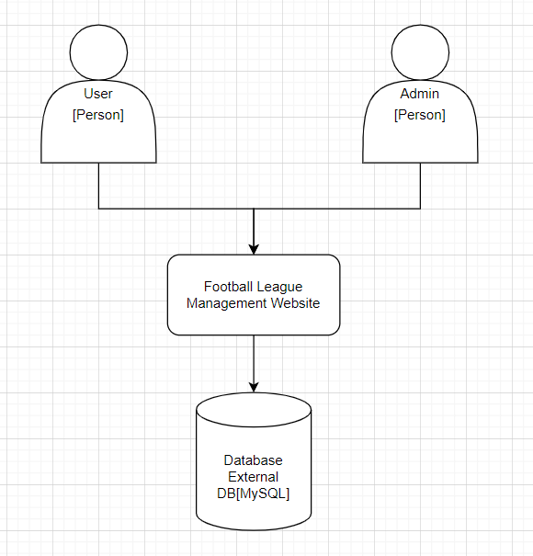

There is 2 types of people who can access the website: the user and the admin, each of them have a different view.
The users (players, team managers and referees) will all have different view. The players can view their statistics, team managers can modify their team and referees can enter match results. All of these functionalities can be used once the users are logged in, if they are not logged in they can view the home page as well as the league table, fixtures and results.
The admin can create, delete, update and view all users and matches. He can manually reset the password for every user by just entering their email and the backend will send an email to that users email.
Ideally the player and team manager will be able to communicate via the website.

4.2 C2 - Containers

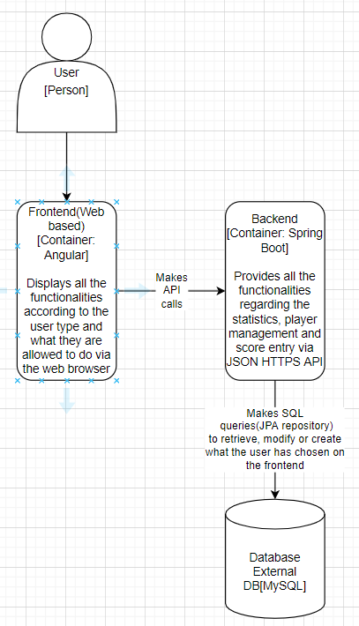

The web application is divided into 3 main parts: Frontend(Angular) responsible to display the user interface and take form data that the user submited and sending API calls to the backend, Backend(Java Springboot) responsible for receiving, creating or modifying and giving the frontend the data from the backend and the database(MySql) responsible for data storage for users, matches, teams and join tables like player-team-join.

4.3 C3 – Component Diagram
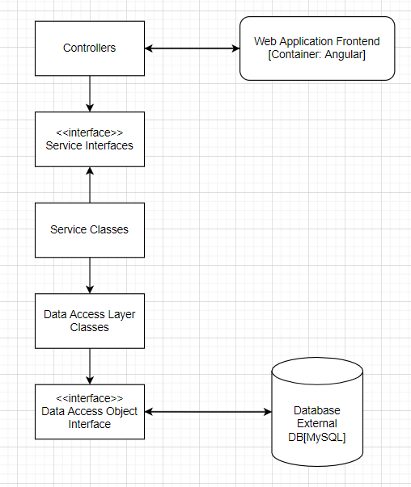

These are the components which help me form the backend.

4.4 C4 – Class Diagram

